**Draft a PeopleAdmin Posting (Instructional/Executive)**

1. Log in to PeopleAdmin using <https://jobs.wm.edu/hr/sessions/new> and the *SSO (single sign-on)* link.

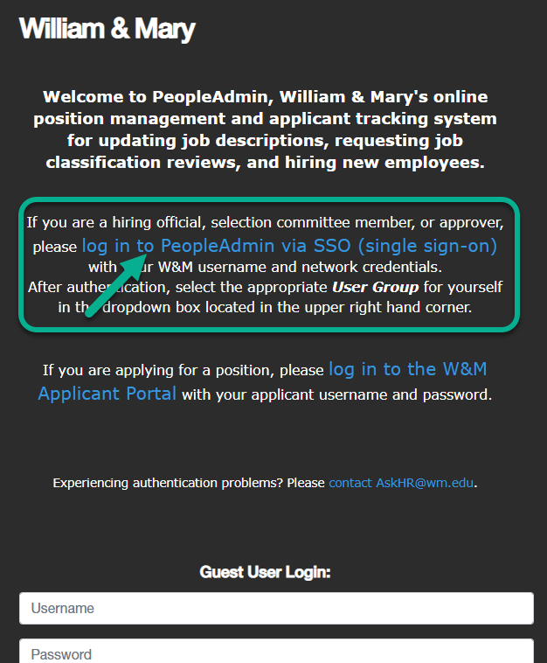

1. In the upper right-hand corner, change your user group to “*Hiring Official.”*

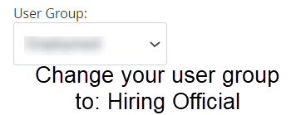

1. On the blue ribbon at the top of the screen, click “*Postings”*, then “*Instructional/Executive.”*

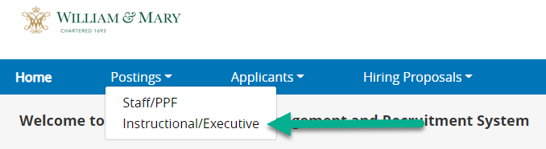

1. Click the orange button with text “*+Create New Posting.*”

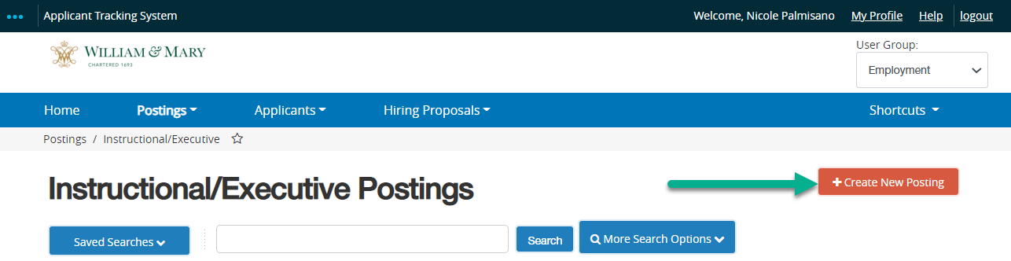

1. Select “*Create from Position Description.*”

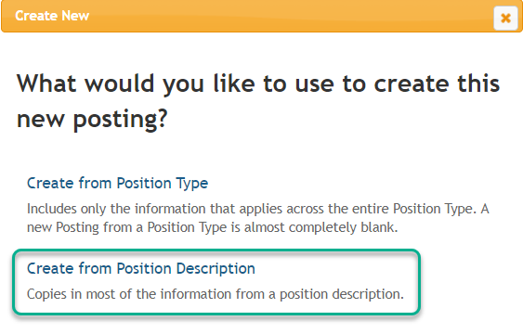

1. Using the search box, type the approved position number. For more search options, click “*More Search Options”* box then click “*Search*”.

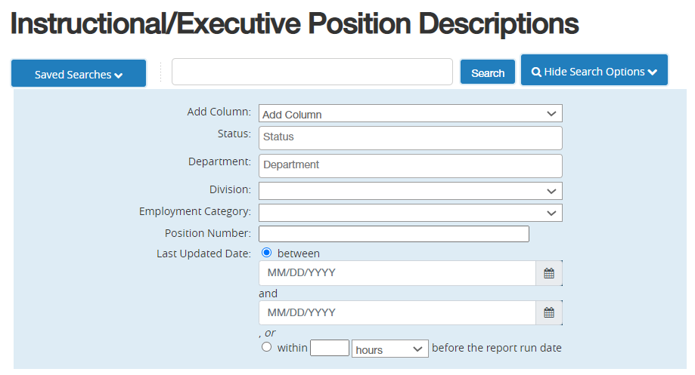

1. In the row containing the correct position, hover over the red “*Actions*” text on the right-hand side and click “*Create From.*” Please ensure the selected position is the approved, most recent version of the position description. If appropriate, click on the description to review. For troubleshooting contact the Talent Acquisition Team.

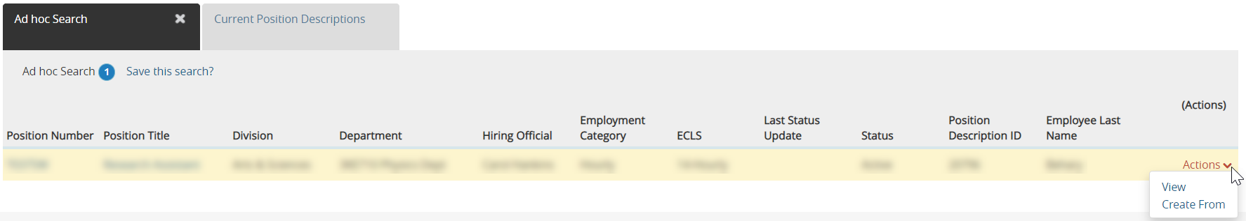

1. PeopleAdmin will transition to a New Posting page. Most content auto-populates from the position description. Unless instructed otherwise, leave auto-populated content as-is.

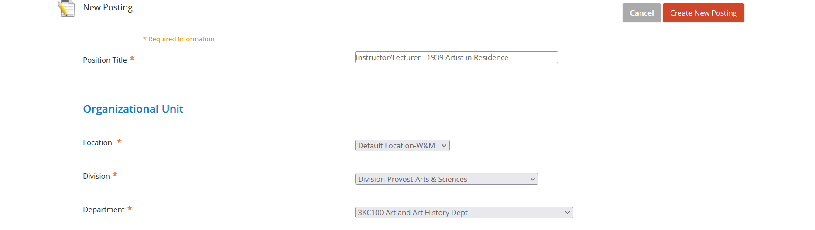

1. Select one appropriate job alert from the list; this will trigger email notifications to job seekers that have opted in.

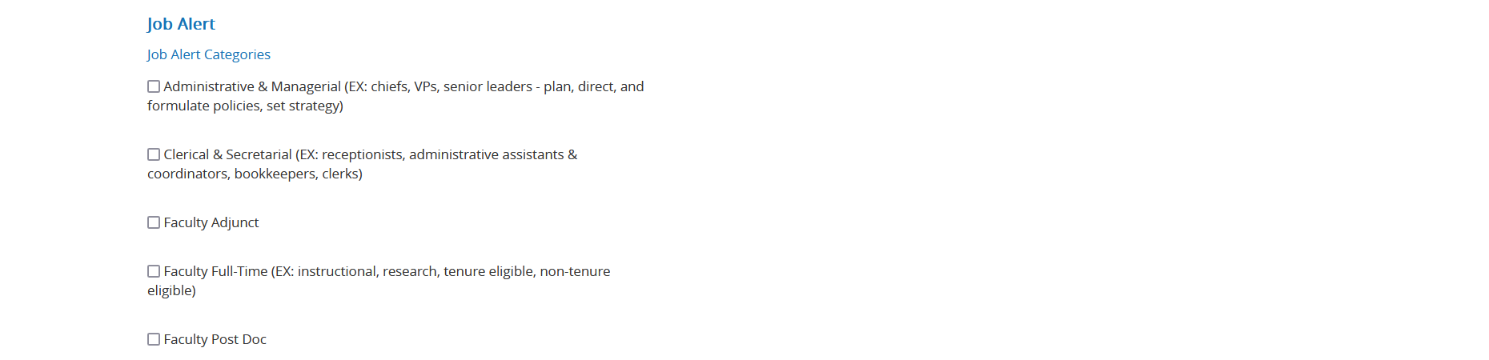

1. If not already selected, choose an initial Workflow State of “Under Review by Search Manager.”



1. Advance to the References section. In this pilot year, the recommendation letter feature shall be used for full-time faculty positions at the L**ong-List (Interview Pending) Workflow State.** The feature shall not be used for adjunct positions. Adjunct positions shall utilize reference check calls prior to the hiring proposal stage. Please make the following selections:

|  |  |  |
| --- | --- | --- |
|  | Full Time Faculty | Adjunct Faculty |
| Reference Notification | Long List Interview Pending | Blank |
| Recommendation Workflow | Long List Interview Pending | Blank |
| Recommendation Document Type | Recommendation | Blank |

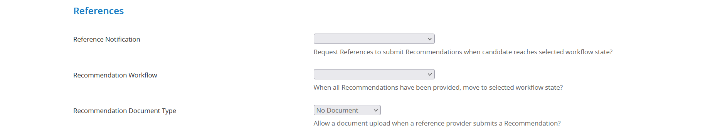

1. Select the box “*Accept online applications*” and then check the box for “*Faculty*.”

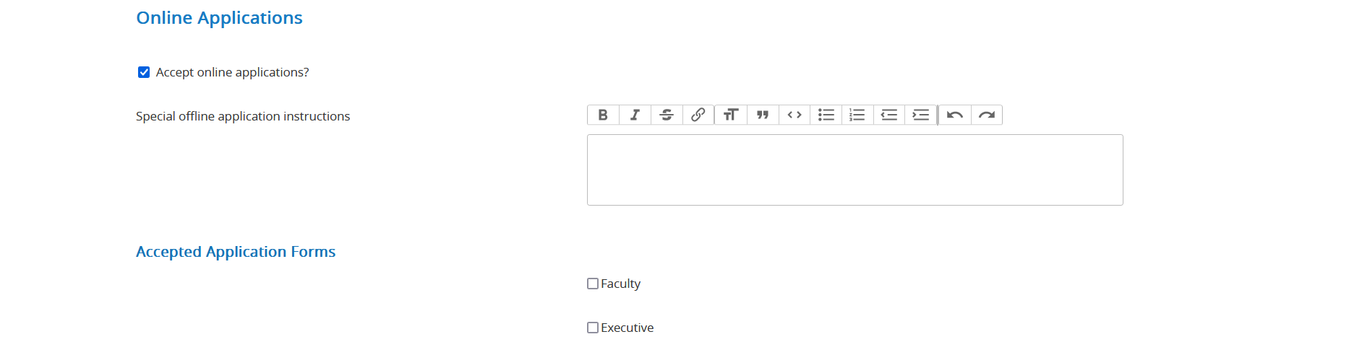

1. Leave the Position Description Documents unchanged, then click “*Create New Posting*.”

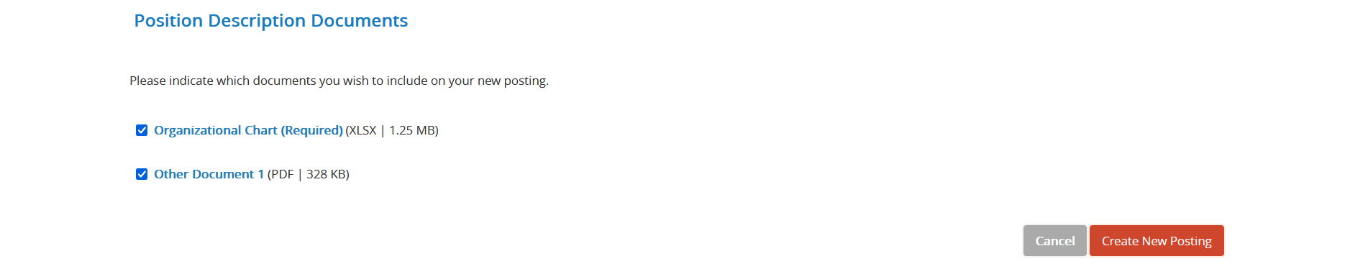

1. PeopleAdmin will transition to the Posting Details Tab. Leave auto-populated content as is. Input the anticipated search launch date, which should coincide with the launch of advertising. You will need to retain/ upload any ad proofs at the end of the search. Select “*General Public*” as the audience unless you have special permission from unit leadership and UHR to launch an agency-only search.



1. Enter all advertising sources prior to submitting the posting. It is important to determine and coordinate advertising prior to launch. UHR will advertise in HigherEdJobs and the W&M Employment Site. Any additional advertising must be arranged and paid for by the unit. Note the Quick Link for advertising/ networking purposes.

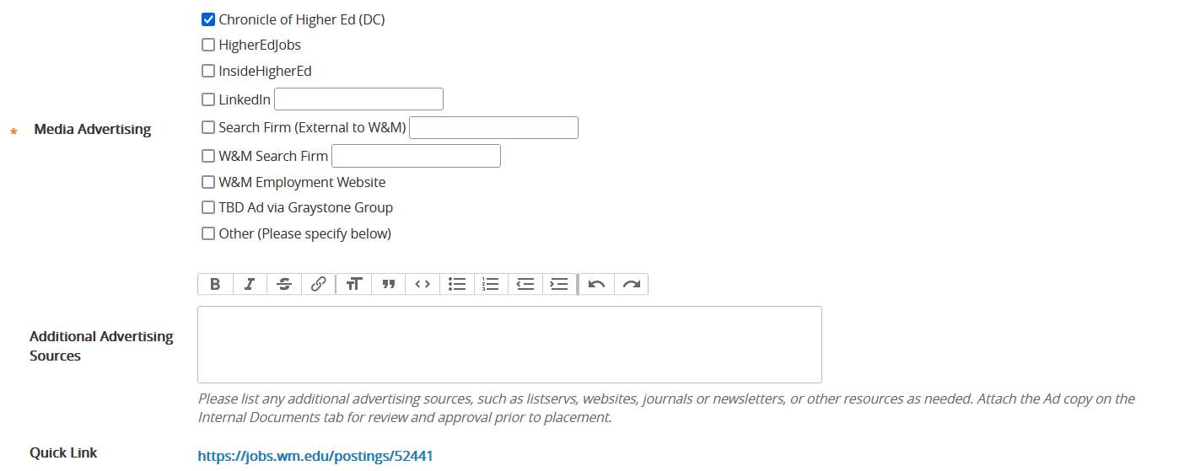

Reminder: **All text-rich advertisements must include the complete EEO statement and link to the full posting**

* William & Mary values diversity and invites applications from underrepresented groups who will enrich the research, teaching and service missions of the university. The university is an Equal Opportunity/Affirmative Action employer and encourages applications from women, minorities, protected veterans, and individuals with disabilities.

**Any social media or brief advertisements must state the following (may add VIMS).**

* William & Mary is an EEO/AA institution. For full description and to apply, visit [insert link]

1. Select the correct “*Location*” from the dropdown. If the “*Position Title*” is generic (i.e. Assistant Professor) you may edit it for recruitment visibility purposes (i.e. Assistant Professor of Biology).



1. Review the “*Unit Mission Statement*”. This statement should be School-approved, brief text (two sentences maximum is suggested). If lengthy, consider truncating or inserting a link to a department About page.

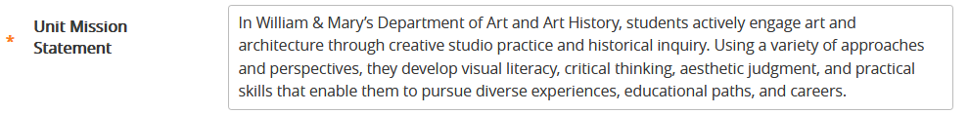

1. Do not alter the “*Qualifications”* *or “Conditions of Employment”* fields unless instructed by University Human Resources.

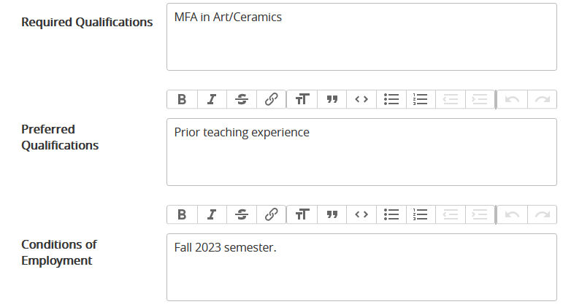

1. Input a “*Job Open Date*”. This date is typically the next business day. The TAT team will adjust if posting is delayed.

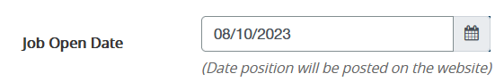

1. Input an accurate “*Review Date*” per the pre-established search timeline. Applications received by this date may receive priority consideration. This date must be at least thirty days in the future. To request an expedited search, contact the Talent Acquisition Team.



1. It is suggested that the department not choose a “*Job Close Date*” and choose “Yes” for “Open Until Filled. The department may contact TAT to close the posting to new applicants when a satisfactory applicant pool exists.

For time-sensitive searches (i.e. near-term adjunct vacancies) the department may choose a Close date 30+ days in the future or discuss an expected search with the Talent Acquisition Team.

Yes



1. Leave the following fields as-is; if changes are requested, contact the Talent Acquisition Team.

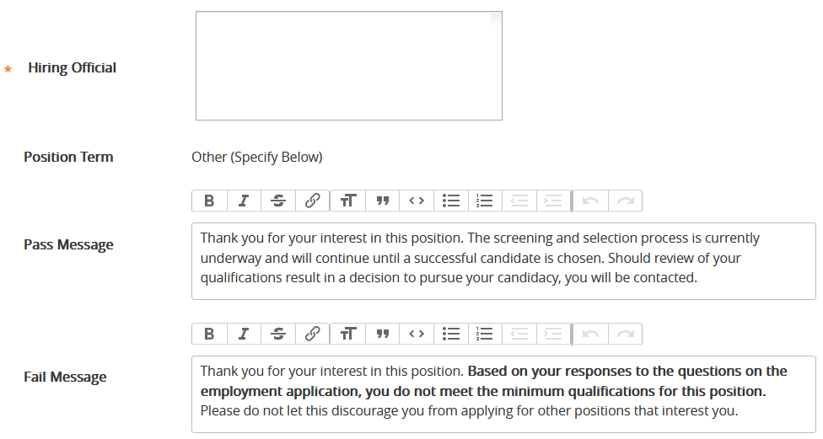

1. Enter any “*Special Application Instructions*.” Ideas include:
   1. **Full-time positions**: “The application will request contact information for references/ recommendation letter writers. Letters will be collected for a select group of advancing applicants, later in the search process.”
   2. **If specifying a review date:** “For priority consideration, please apply by the review date.”
   3. **If requesting a writing sample**: “Please upload a sample of 300-500 words under the “Other Documents” link.”
   4. **Emergency/ expedited searches:** “Review will begin immediately.”
   5. **Rolling adjunct pool:** “We are recruiting a pool of applicants for possible part-time adjunct teaching opportunities. This pool will be reviewed as needs arise. Applications remain valid for the duration of the posting, but no more than one year from the original posting date of the opening. After a posting concludes, interested job seekers may re-apply to an available posting. Only those applications selected for an interview will be contacted about the opportunity.”



1. Do not alter or add to the “*EEO Statement*” or “*Background Check Statement*” in any way. Departments may not add school-specific diversity statements to postings (in any field) for legal/compliance reasons.

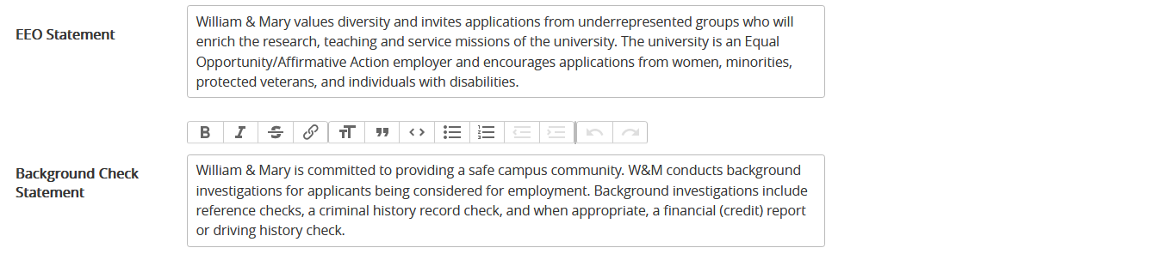

1. Review or populate the “*Benefits Summary Statement*” based on the position type and help text instructions. Do not divert from boiler plate text. It’s essential that we advertise the correct, approved language only. If you are uncomfortable selecting the correct text, alert the Talent Acquisition Team.

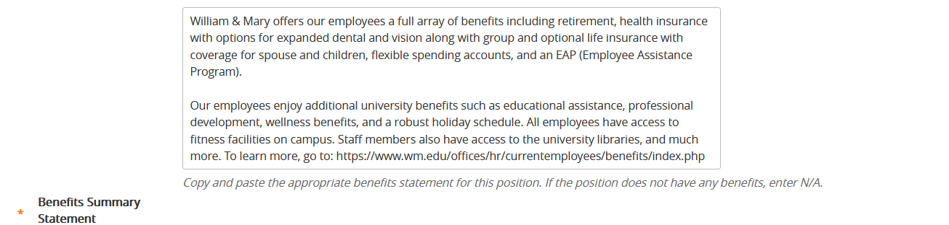

1. Click “*Save & Continue*.”



1. PeopleAdmin will progress to the Recommendations tab. For full time positions select “Yes” and for adjunct position select “No.” Then “*Save and Continue*.”



1. Departments may add up to five Supplemental Questions by clicking “*Add a Question.*” Questions should be brief or forced choice. Departments may make closed-ended questions disqualifying, however disqualifying questions must be tied to required qualifications. For example, if a required qualification lists an earned Ph.D., one could ask “Do you or will you have an earned Ph.D. by [insert start date].” In-depth questions should not be addressed through Supplemental Questions. Instead, request an attachment in the Applicant Documents section, or address later in the process, such as via Interview Stream. Contact the Talent Acquisition Team for InterviewStream support. Click “*Save and Continue*.”

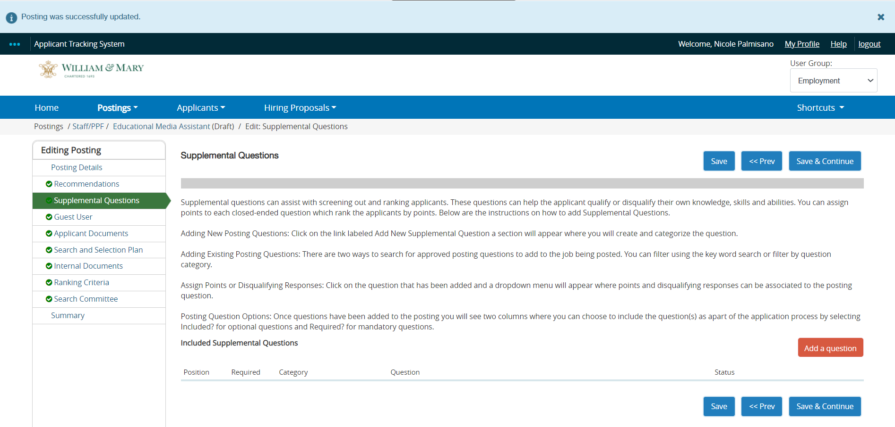

1. Establish “*Guest User Access*” only when a Search Committee member is outside of the William & Mary community. For this access, contact the Talent Acquisition Team. Click “*Save and Continue*.”

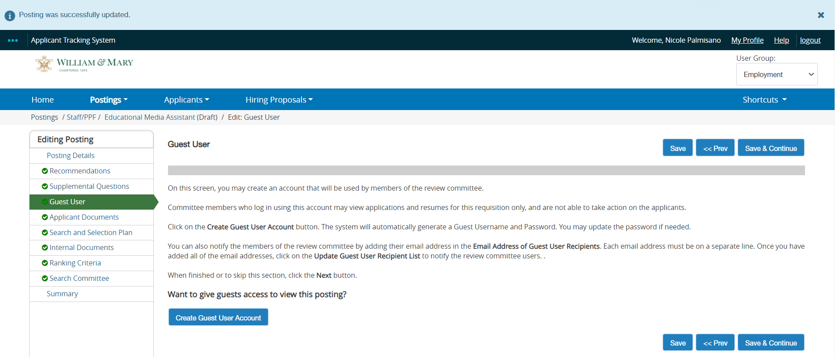

1. Select required and optional documents for your posting. A CV and cover letter are required for all postings. Additional options are listed below. If you require a document other than the CV or cover letter, please specify expectations in the previous “*Special Instructions*” section. Click “*Save and Continue*.”

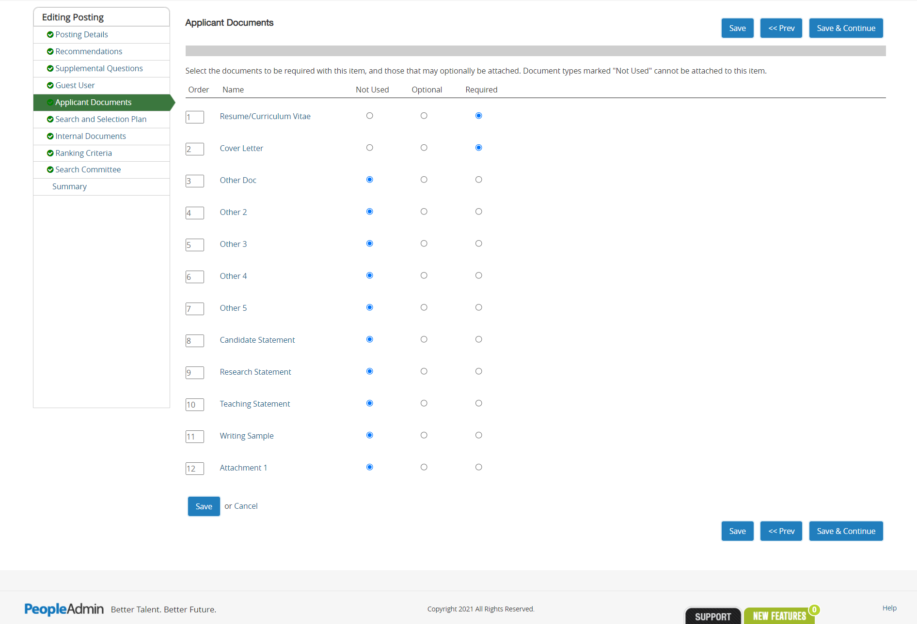

1. The “*Search and Selection Plan”* section will populate. Here, list the names of the Search Committee members. This information is necessary for audit reasons.



1. “*List all evaluation tools to be used during selection*” is a required field and includes all steps and tools in the evaluation process. This field will be consulted in the event of an EEO complaint, audit, or applicant challenge; please obtain from the Search Chair.

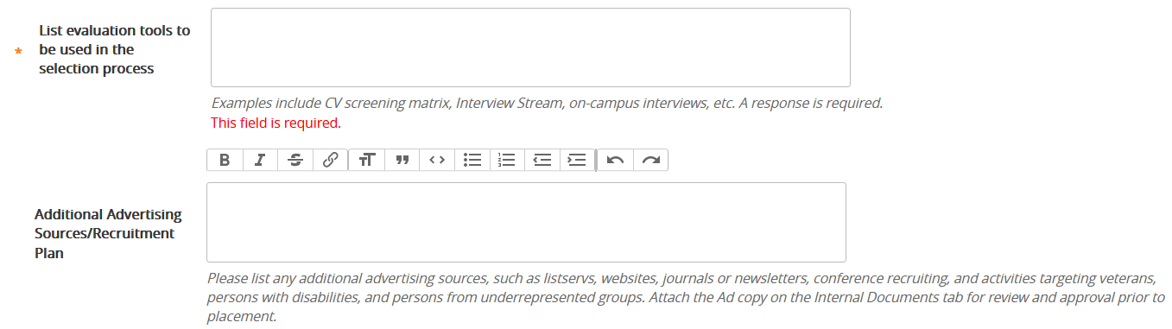

1. (Optional) Use “*Additional Advertising Sources/ Recruitment Plan*” to reflect any recruitment plans not previously captured. This section could include networking or other non-advertising sources. Click “Save and Continue.”

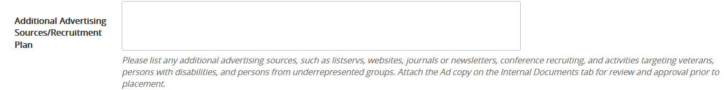

1. (Optional) Upload internal documents you would like to include in the posting. Frequently used: Search Waiver, important emails, draft screening grids. Click “*Save and Continue*.”

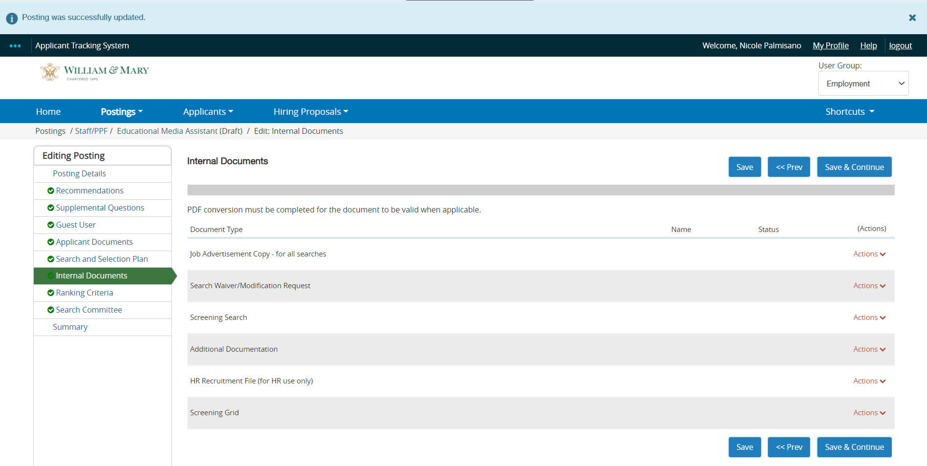

1. Do not include Ranking Criteria. We do not use this feature. Click “*Save & Continue*.”

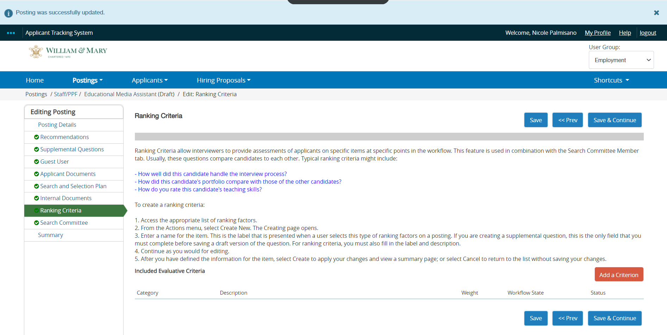

1. Add Search Committee Members by clicking “*Add Existing User*”. This step gives committee members access to the posting. If unable to add a member, request the TAT Team troubleshoot after submitting.

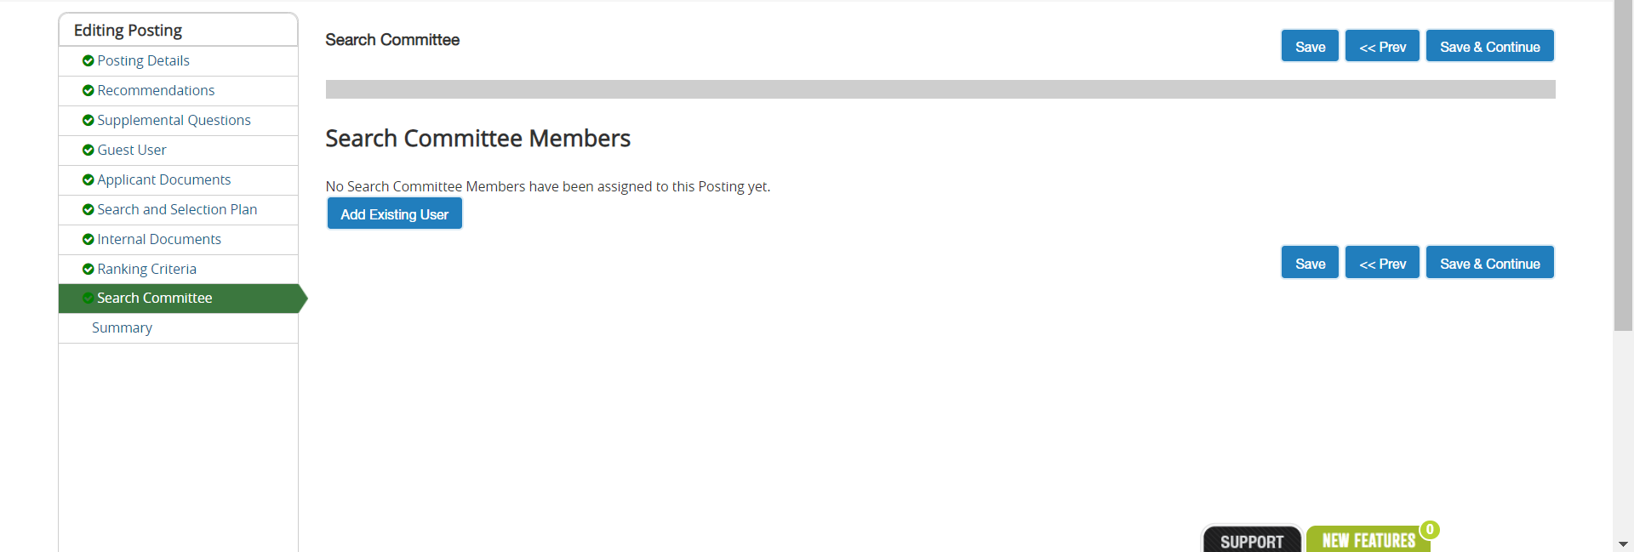

1. Uncheck the box next *to “Display search committee user group member only”*. If left checked, you will only see employees who have served on search committees in the past. Only William & Mary/ VIMS employees will appear.

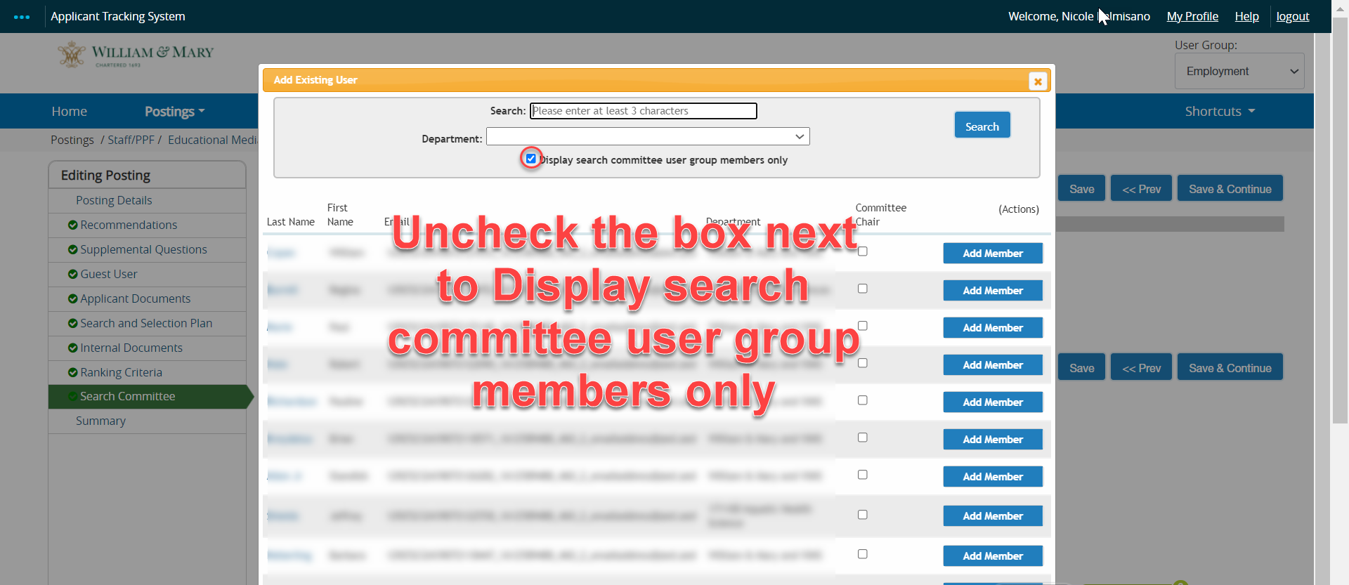

1. In the search field, type in the employee’s name. If the employee’s name does not appear, please contact the Talent Acquisition Team.
   1. If the employee is the committee chair, click the box under committee chair then click “*Add Member”*
   2. If the Search Committee member is not the Committee Chair, simply click “*Add Member”*
   3. Once you have added all committee members, close out by clicking the “X” in the orange banner

**NOTE:** If you see multiple employees with the same name, you can identify the correct individual by matching their email address

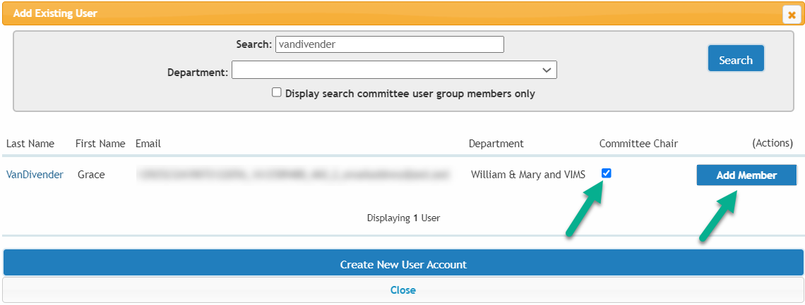

1. Once the *Add Existing User* box has closed, the page will reload and the members you have added will populate. When done, click “*Save and Continue*.”

**NOTE:** Committee members who have not served on a committee in the past will show as pending. Talent Acquisition Team can approve them.

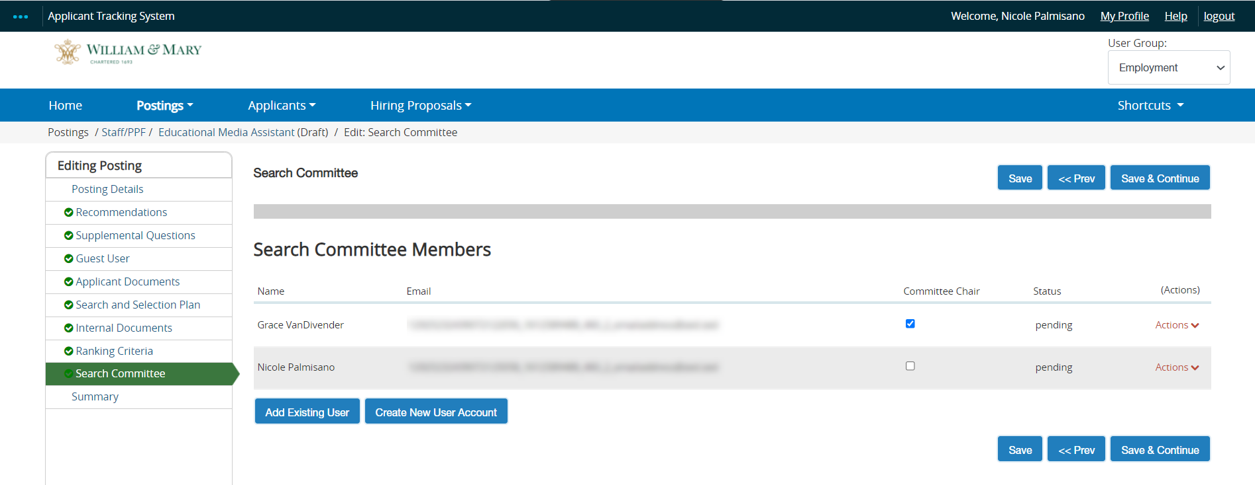

1. The posting Summary will load for review. If edits are necessary, access the appropriate section on the left menu, then click “Edit.” Click “Save” after any edits. To get back to the Summary page, click “Summary on the left menu.”
2. When ready to advance the posting for approval, email your Talent Acquisition Partner and transition the position to Employment. There is no need to send an email to the TAT team. They will be notified that you are ready for posting review.
3. Once reviewed, that Talent Acquisition Partner will post the position will appear on <https://jobs.wm.edu/>