- Buy Something

- Hardware & Accessories

- New Lease Computer Order
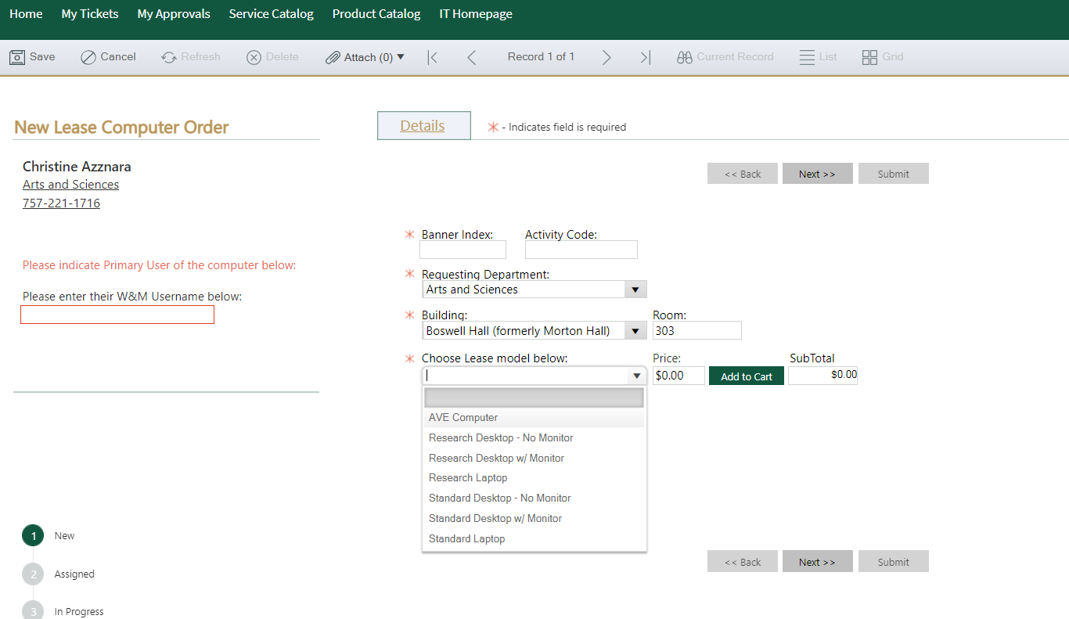
- Enter Banner Index, Requesting Department, Building, Room, Select the AVE computer from drop down, click green “add to cart” button. Then next.

